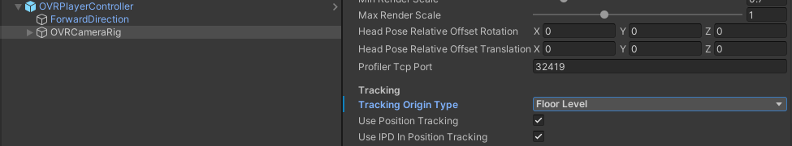

(Above) Camera-controlled height adjuster

(Below) Script-controlled height adjuster

